Introduction:
- Why females?
  - Simpler dynamics : no skip-moulting,
  - No effect of the fishery
  - Spawning stock dynamics.
Methodology:

Female population model:
- A stage-structured population model was constructed for female snow crab using 1997-2025 data from the southern Gulf of Saint Lawrence snow crab trawl survey.
- The main goals of the exercise were to estimate recruitment, mortality and make short-term spawning stock projections.
- Females were divided into four stages: immature, pubescent, new-shelled matures and old-shelled matures.
- Stages were visually identified using the relative size of the abdomen (i.e. morphometric immature), gonad colour and the condition of the shell (Table 1).
- Immature and pubescent females both had small abdomens and do not carry eggs, but pubescents had developing orange-colored gonads, rather than small white or beige gonads, as was the case for immatures.
- New and old-shelled females both had large abdomens morphometrically and the presence of eggs, but are differentiated on the basis of their shell condition, with new-shells corresponding to shell conditions 1 or 2 and old-shells corresponding to shell conditions 3, 4 or 5.

Table 1 : Description of stages used in the population model for female snow crab.
Stage | Label | Maturity | Identification | Uncertainties
Immature | $$imm$$ | Immature | Small abdomen, small white or beige gonads | Low trawl catchability.
Pubescent | $$pub$$ | Immature | Small abdomen, larger orange gonads | Low trawl catchability.
New-shells | $$new$$ | Mature | Large abdomen, shell conditions 1 or 2 | Some misidentification of shell condition 2s & 3s during survey.
Old-shells | $$old$$ | Mature | Large abdomen, shell conditions 3, 4, or 5

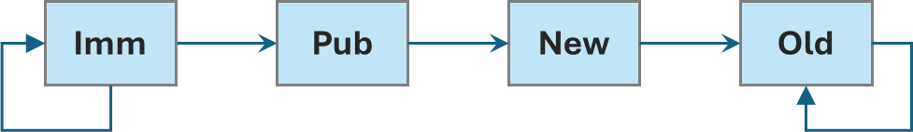

Figure 1 : Stage transitions of the population model.

- A portion of the immature category and all of the old-shelled category cycles into itself from year to year.
- The duration of the pubescent and new-shell stages is assumed to be a single year.
- In other words, all pubescents become new-shelled matures, and all new-shelled matures become old-shelled matures the following year.
- The immature category is renewed by varying levels of population recruits every year (not observed).
- A portion of larger immatures (i.e. instars VI, VII and VIII) become pubescents the following year.
- Old-shelled females are divided by year-class within the model. This allowed for age-specific mortality estimates.
Model definition:
- We now formally define the model:
  - Let $N_{y}^{(imm)}$, $N_{y}^{(pub)}$, $N_{y}^{(new)}$, $N_{y}^{(old)}$ represent the abundance estimates for immatures, pubescents, new-shelled matures and old-shelled matures, respectively, where $y$ is an index of the survey year.
  - Let the old-shells $N_{y}^{(old)}$ be divided into 7 year-classes, $n_{yj}^{(old)}$, where $j=1,…,7$, and $N_{y}^{(old)}=\sum_{j=1}^{7}{n_{yj}^{(old)}}$.

- Recruitment, maturation and mortality were all modelled as time-varying random effects.
- Let $R_{y}$ be the recruitment to the immature stage in year $y$.
- The stage transitions are mediated through maturation and mortality processes.
  - Let $p_{y}$ represent the annual proportion of immatures maturing to pubescents.
  - Let $M_{y}^{(imm)}$, $M_{y}^{(imm-pub)}$ and $M_{y}^{(pub-new)}$ represent time-varying mortalities between the immature to immature, immature to pubescent, and pubescent to new shell transitions.
  - Now let $M_{y}^{(new-old1)}$, $M_{y}^{(old1-old2)}$, …, $M_{y}^{(old6-old7)}$ represent the time-varying mortalities between all of the mature year-classes.
  - Recruitment, maturation and mortality effects were modelled as AR-1 processes over survey year.
- Immatures and pubescents were rescaled to the mature stages, in order to account for their lower trawl selectivity, using selectivity parameters $S^{(imm)}$ and $S^{(pub)}$.
- There have been 5 survey vessels since 1997, the Emy Serge D. (1997-1998), the Den C. Martin (1999-2002), the Marco-Michel (2003-2012), the Jean-Mathieu (2013-2018) and the Avalon Voyager II (2019-present).
- Vessel catchabilities $C_{1}$, $C_{2}$, $C_{3}$ and $C_{4}$ were estimated for each of the first four survey vessels, in order to calibrate abundances relative to the CFV Avalon Voyager II.
State equations:
Stage | State equations
Immature | $$N_{y+1}^{(imm)}=R_{y}+M_{y}^{(imm)}(1-p_{y})N_{y}^{(imm)}$$
Pubescent | $N_{y}^{(pub)}=M_{y}^{(imm-pub)}p_{y}N_{y}^{(imm)}$
New-shelled | $$N_{y}^{(new)}=M_{y}^{(pub-new)}N_{y}^{(pub)}$$
Old-shelled | $$N_{y}^{(old)}=M_{y}^{(pub-old1)}N_{y}^{(new)}+\sum_{j=1}^{7}{{m_{y}^{(j,j+1)}n}_{yj}^{(old)}}$$

Statistical formulation:
- Let the estimated abundances (estimated abundance indices) be represented as ${\hat{N}}_{y}^{(imm)}$, ${\hat{N}}_{y}^{(pub)}$, ${\hat{N}}_{y}^{(new)}$ or ${\hat{N}}_{y}^{(old)}$ and their corresponding standard errors ${\hat{s}}_{y}^{(imm)}$, ${\hat{s}}_{y}^{(pub)}$, ${\hat{s}}_{y}^{(new)}$ or ${\hat{s}}_{y}^{(old)}$.

Equation
$${\hat{N}}_{y}^{\left(imm\right)}$$ | $$\sim$$ | $$Normal(N_{y}^{(imm)}, { \hat{s}}_{y}^{(imm)})$$
$${\hat{N}}_{y}^{\left(pub\right)}$$ | $$\sim$$ | $$Normal(N_{y}^{\left(pub\right)},{ \hat{s}}_{y}^{(pub)})$$
$${\hat{N}}_{y}^{\left(new\right)}$$ | $$\sim$$ | $$Normal(N_{y}^{\left(new\right)}, s_{y}^{(new)})$$
$${\hat{N}}_{y}^{\left(old\right)}$$ | $$\sim$$ | $$Normal(N_{y}^{(old)}, { \hat{s}}_{y}^{(old)})$$

- Abundance and standard errors were estimated for each stage was estimated using kriging (Surette et al. 2006) using sGSL snow crab survey data from 1997 to 2025.
Bayesian priors:
- $\log\left(R_{y}\right) \sim AR1(φ_{R})$, $φ_{R} \sim U(0,1)$
- $logit(p_{y}) \sim AR1(φ_{p})$ , $φ_{R} \sim U(0,1)$
- $M_{y}^{(.)}\sim AR1(φ_{M})$ , $φ_{R} \sim U(0,1)$
- Selectivity effects (immatures and pubescents, plus vessel effects) were given uniform priors over [0,1]. $S_{imm} \sim U(0,1)$, $S_{pub} \sim U(0,1)$, and

Model fitting :
- The model was implemented in OpenBUGS (Sturtz et al. 2005).
- A burn-in period of 10,000 iterations was performed and 100,000 MCMC samples were generated.

Sturtz S, Ligges U, Gelman A (2005). “R2WinBUGS: A Package for Running WinBUGS from R.” Journal of Statistical Software, 12(3), 1–16. doi:10.18637/jss.v012.i03.
Results:
- Female spawning stock is declining and is slated to decline further in 2026-2028.
- The lows during this period will be comparable to the low levels from 2006-2009, at about 250-275 million crab or so.
- A period of low primiparous abundance is driving this decline in mature females, which are mainly composed of multiparous females.

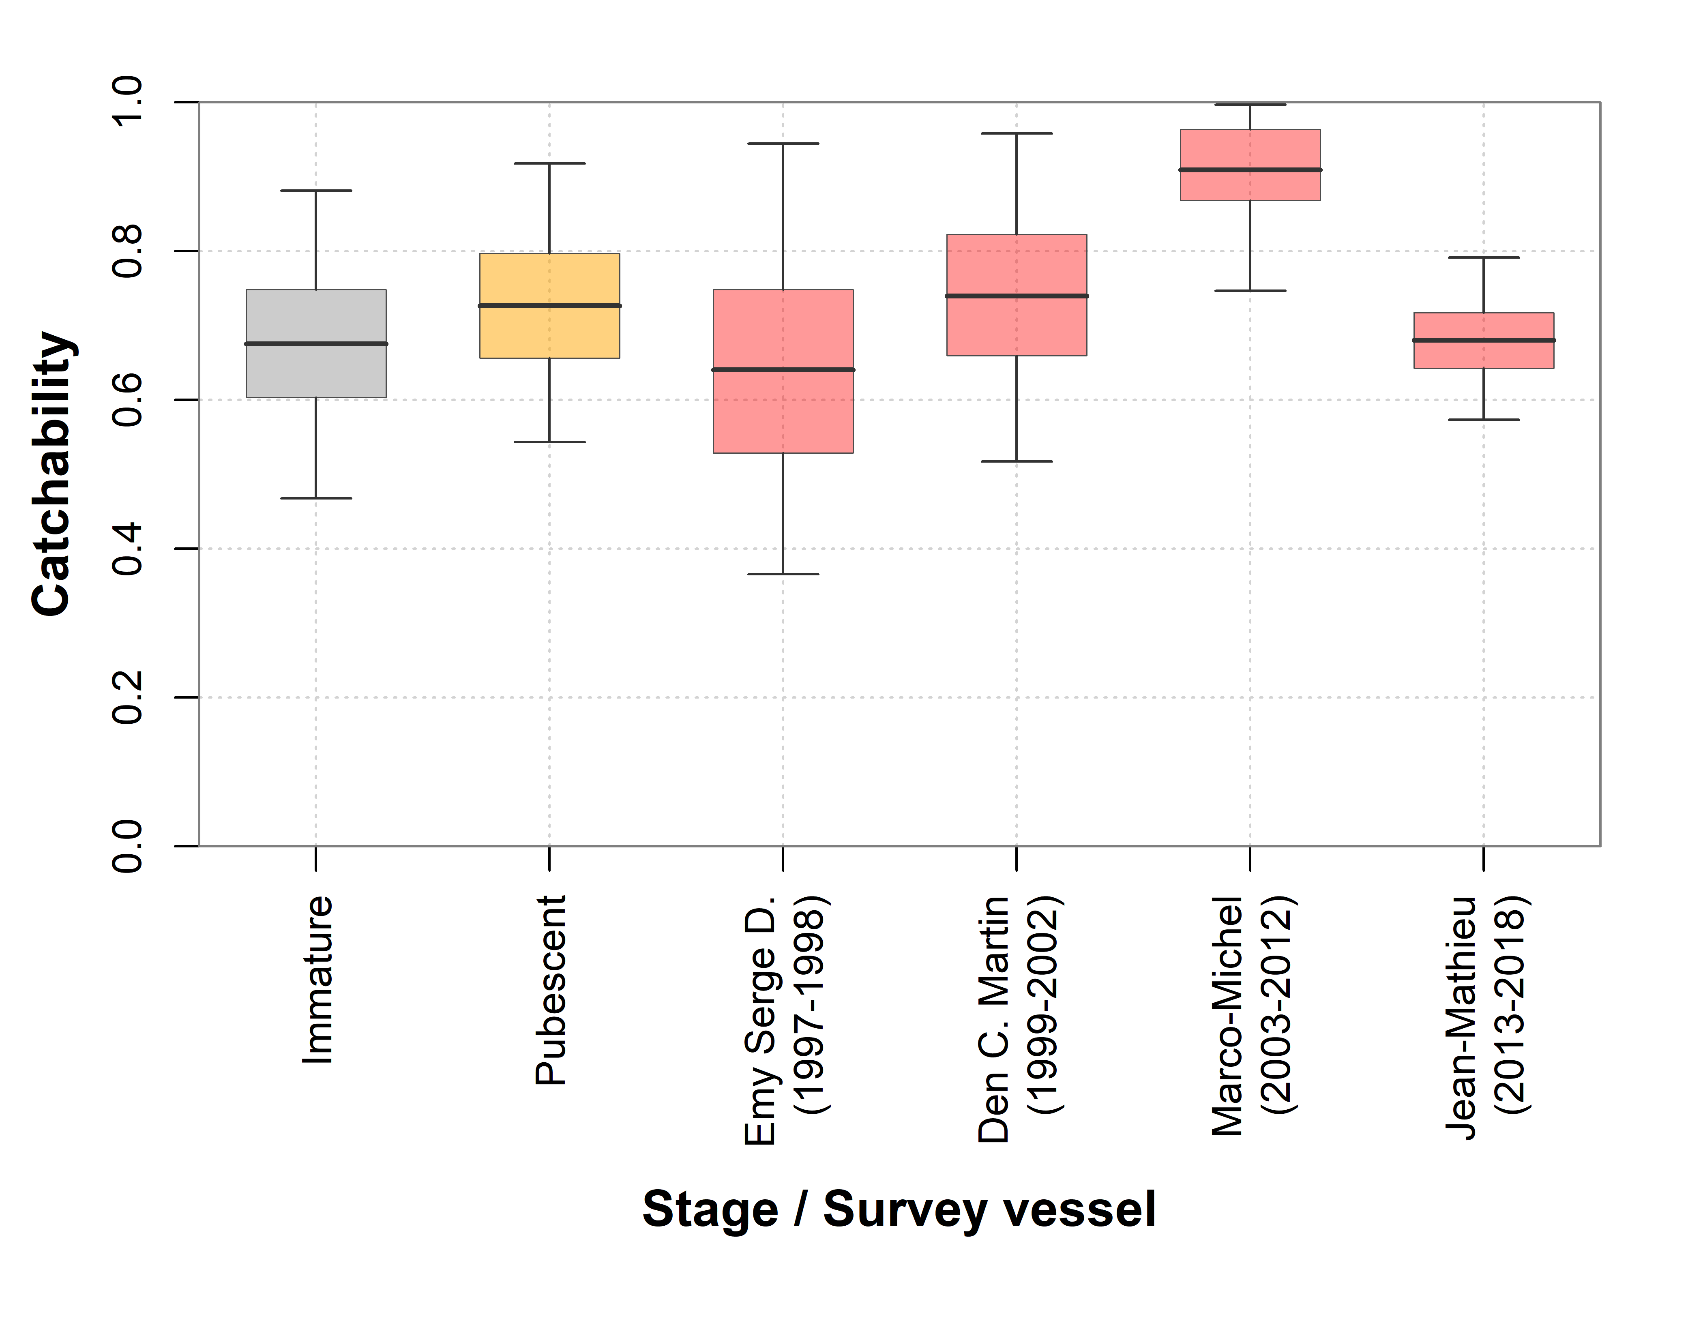
Figure 2 : Catchability estimates for the immature and pubescent stages, as well as the survey vessel effects.

Table X : Catchability estimates for the immature and pubescent stages, as well as the survey vessel effects.
Variable | Domain | Mean | Median | Std. Err. | C.I. (95%)
Immature | Immatures | 0.6750 | 0.6733 | 0.1068 | 0.4678 - 0.8811
Pubescent | Pubescents | 0.7265 | 0.7239 | 0.0981 | 0.5433 - 0.9174
Emy Serge D. | 1997-1998 | 0.6403 | 0.6330 | 0.1515 | 0.3659 - 0.9440
Den C. Martin | 1999-2002 | 0.7394 | 0.7390 | 0.1145 | 0.5172 - 0.9577
Marco-Michel | 2003-2012 | 0.9087 | 0.9228 | 0.0683 | 0.7467 - 0.9965
Jean-Mathieu | 2013-2018 | 0.6801 | 0.6791 | 0.0555 | 0.5735 - 0.7912
Avalon Voyager II | 2019+ | - | - | - | -

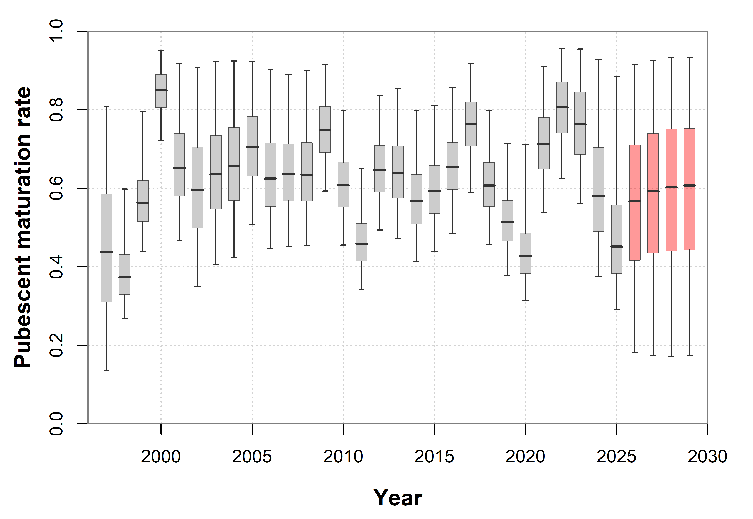
Figure 3 : Annual proportion of immatures from the previous year that became pubescents in the current year.

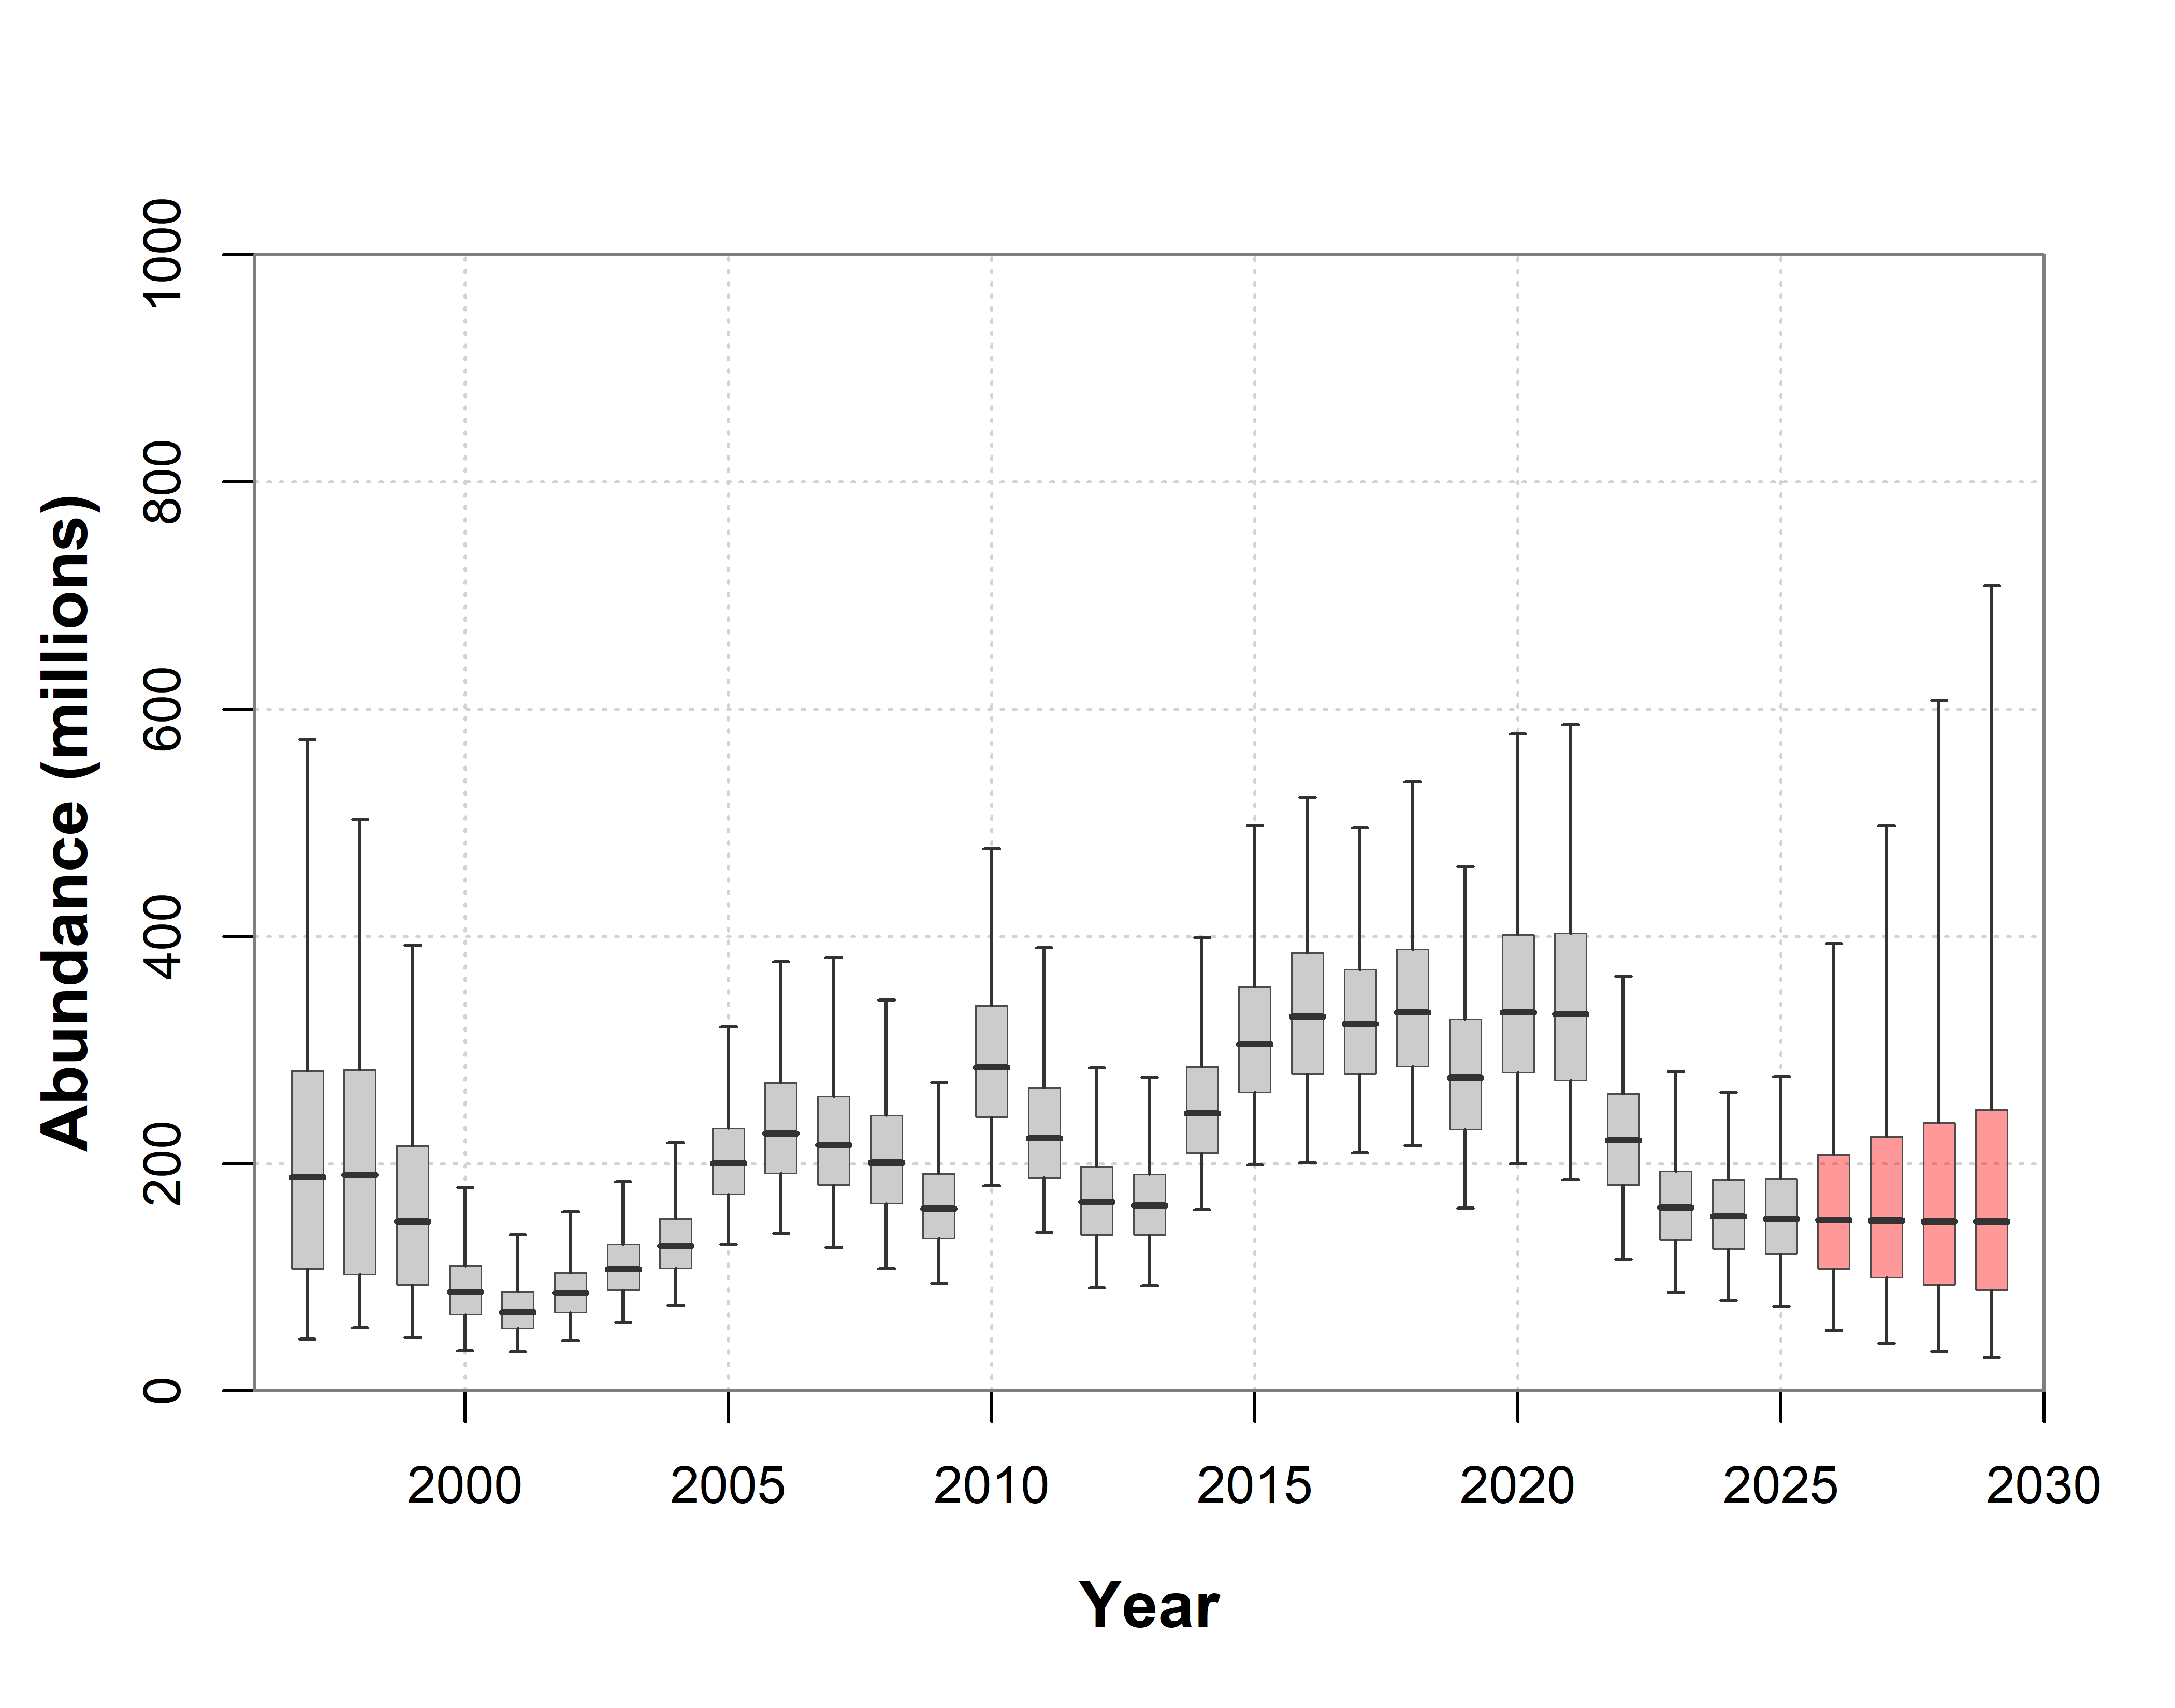
Figure 4 : Annual population recruitment abundance estimates from the population model.

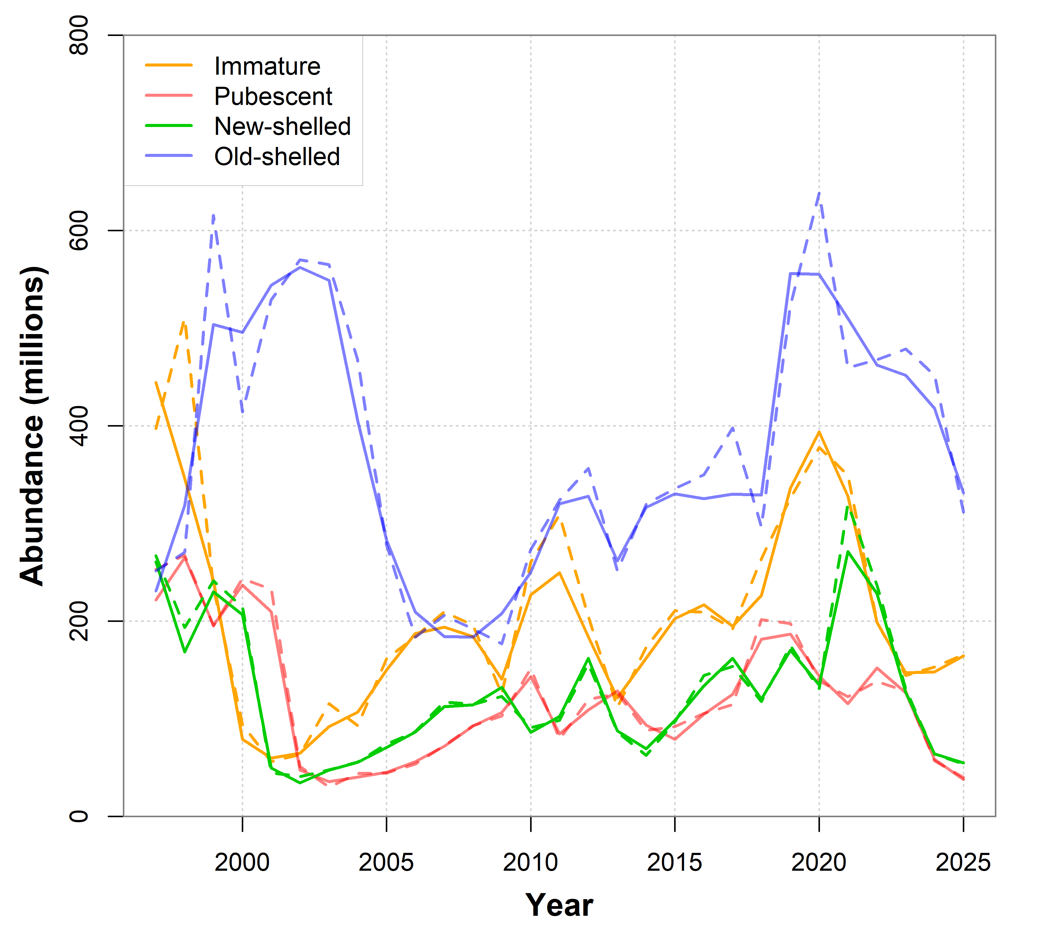
Figure 5 : Comparison of survey abundances from the model (solid lines) and indices (dashed lines).

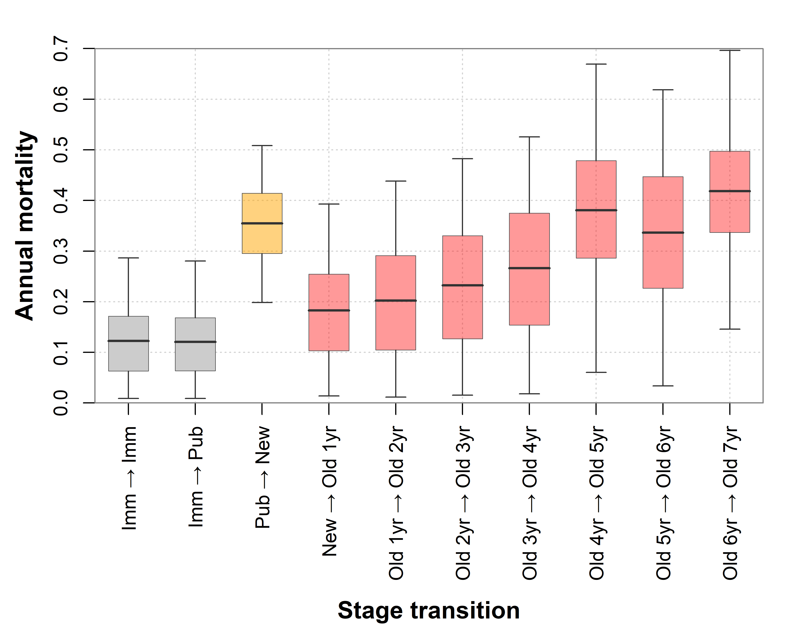
Figure 6 : Average mortality estimates for each of the stage transitions from the population model. Grey boxes correspond to mortalities within the immature and between the immature and pubescent stages. The orange box corresponds to the mortality for the pubescent to new-shelled mature transition, while the red boxes correspond to transitions between the mature year-classes.
- Annual mortalities for the immature/immature and immature/pubescent appear to be relatively low, with a mean of 12%.
- In contrast, the annual mortality for the pubescent/new-shelled mature transition is much higher at 35%.
- One must keep in mind that estimating mortality for the pub/new transition is much more straightforward than for the imm/imm or imm/pub transitions, owing to the fact that there are fewer confounding processes, with only trawl catchability, and possibly shell condition identification, obscuring our perception/estimates or mortality.
- For the immature transitions, additional processes are population recruitment and pubescent maturation.
- Resolving the relative contributions of these processes is difficult, requiring that stronger assumptions be made, which may be biasing mortality estimates in unexpected ways.

- While pub/new mortality is high, once mature, the mortality estimates among new and newer old-shelled mature females, starts at a relatively low 18% for the new/old1 transition but steadily increases to 34-38% among older females, and is estimated to be 42% for the oldest stage considered (between 6.5 and older + year-old crab).

Table X : Average annual mortality rates between maturity stage transitions.
Variable | Mean | Median | Std. Err. | C. I. (95%)
imm-imm | 0.1225 | 0.1126 | 0.07581 | (0.0090 - 0.2865)
imm-pub | 0.1207 | 0.1116 | 0.07391 | (0.0088 - 0.2804)
pub-new | 0.3548 | 0.3558 | 0.08199 | (0.1984 - 0.5083)
new-old1 | 0.1830 | 0.1774 | 0.1022 | (0.0140 - 0.3930)
old1-old2 | 0.2022 | 0.1953 | 0.1192 | (0.0117 - 0.4384)
old2-old3 | 0.2322 | 0.2286 | 0.1304 | (0.0153 - 0.4823)
old3-old4 | 0.2663 | 0.2693 | 0.1420 | (0.0181 - 0.5257)
old4-old5 | 0.3807 | 0.3953 | 0.1509 | (0.0603 - 0.6692)
old5-old6 | 0.3366 | 0.3511 | 0.1555 | (0.0338 - 0.6186)
old6-old7+ | 0.4186 | 0.4242 | 0.1339 | (0.1459 - 0.6962)

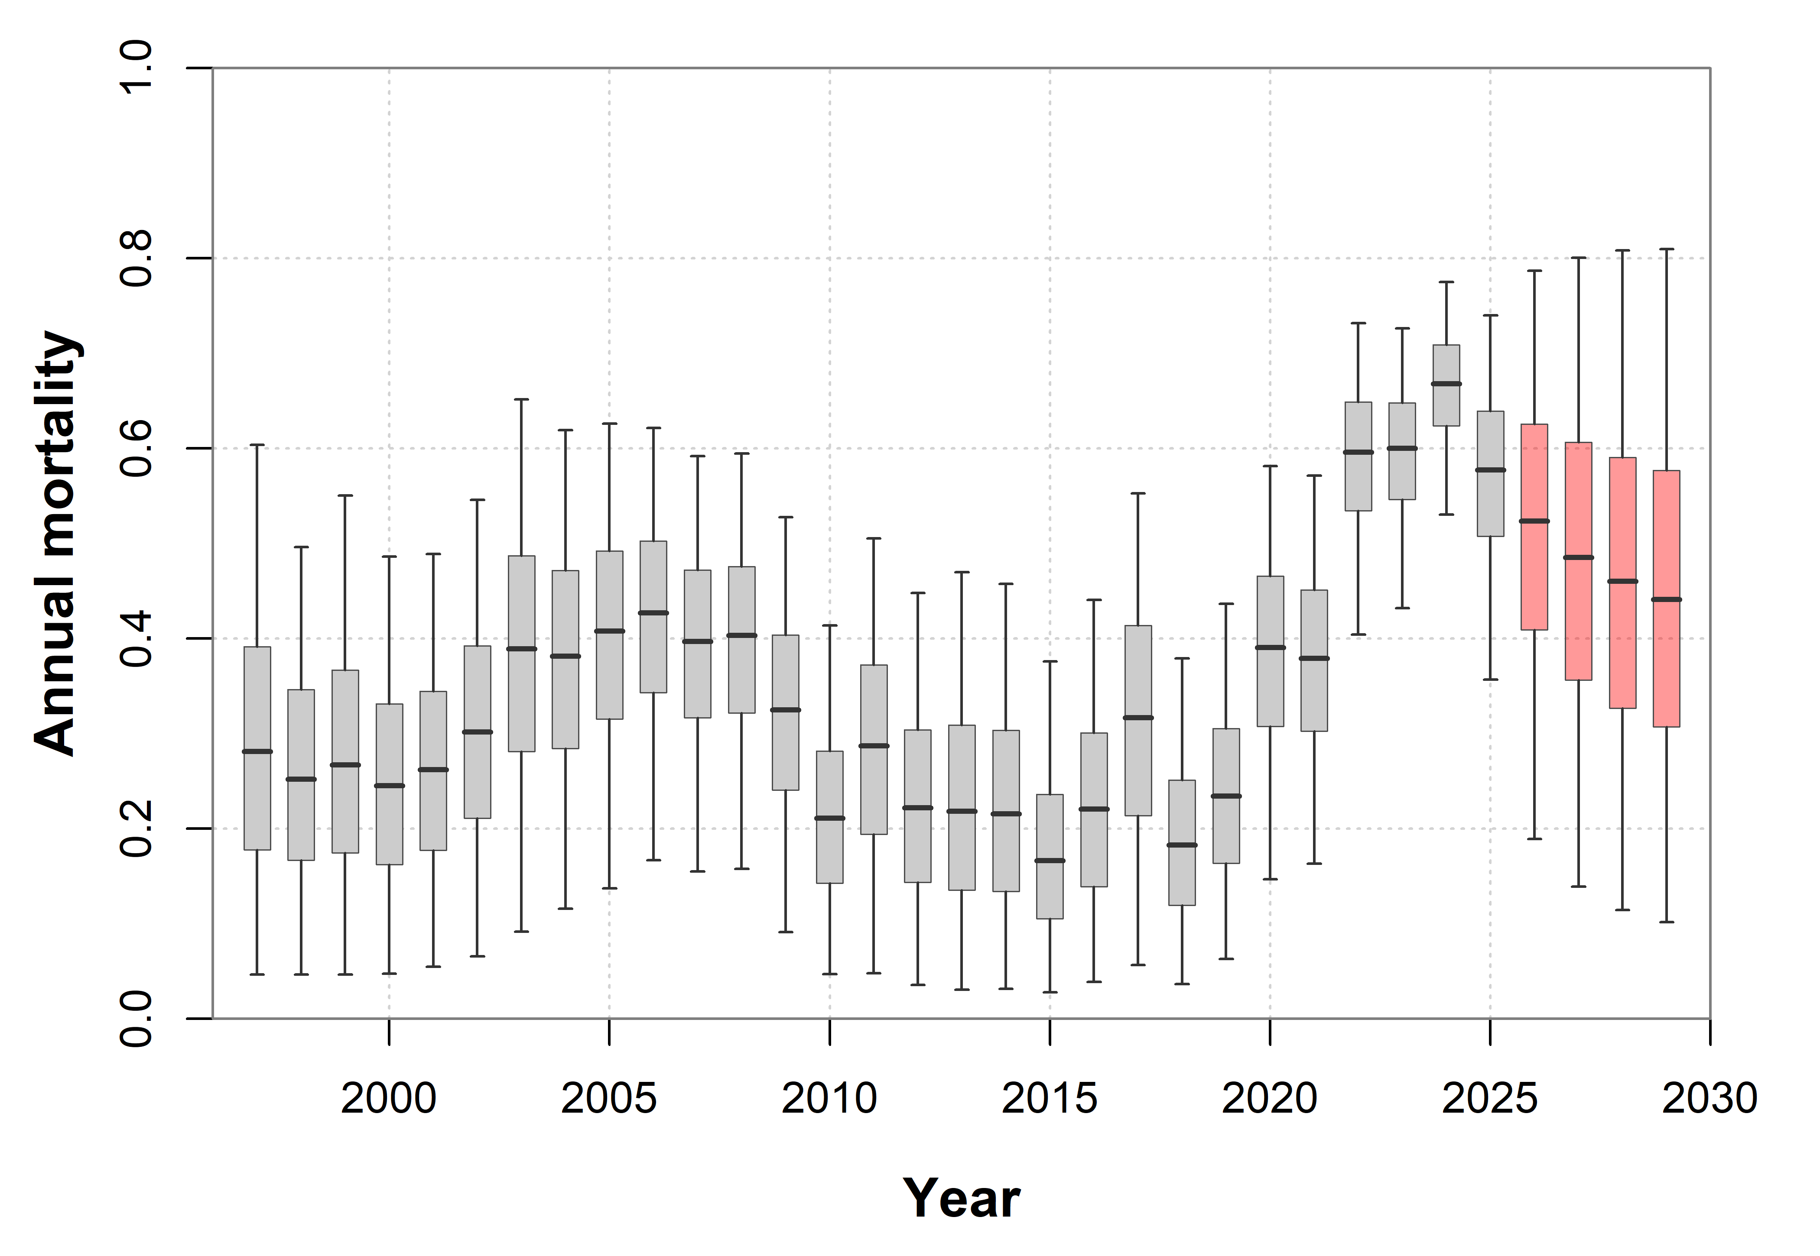
Figure 7 : Annual mortality estimates for the pubescent to new-shelled transition.
- The pubescent to primiparous transition is fairly well behaved and characterized :
- Pubescents are unambiguously identified : immature with orange gonads.
- New-shelled matures are identified using shell conditions.
- Average mortality for the pubescent / primiparous transition is 35.5%.

Table X : Annual mortality estimates for the pubescent to new-shelled transition.
Year | Mean | Median | Std. Err. | C. I. (95%)
1997 | 0.2917 | 0.2813 | 0.1478 | (0.0468, 0.6038)
1998 | 0.2587 | 0.2521 | 0.1203 | (0.0466, 0.4960)
1999 | 0.2751 | 0.2669 | 0.1323 | (0.0465, 0.5501)
2000 | 0.2506 | 0.2454 | 0.1158 | (0.0478, 0.4863)
2001 | 0.2631 | 0.2619 | 0.1142 | (0.0550, 0.4889)
2002 | 0.3025 | 0.3018 | 0.1258 | (0.0660, 0.5457)
2003 | 0.3823 | 0.3889 | 0.1456 | (0.0918, 0.6512)
2004 | 0.3762 | 0.3815 | 0.1314 | (0.1160, 0.6190)
2005 | 0.4000 | 0.4077 | 0.1268 | (0.1374, 0.6257)
2006 | 0.4185 | 0.4270 | 0.1166 | (0.1667, 0.6213)
2007 | 0.3907 | 0.3967 | 0.1127 | (0.1550, 0.5918)
2008 | 0.3953 | 0.4033 | 0.1125 | (0.1578, 0.5947)
2009 | 0.3201 | 0.3247 | 0.1142 | (0.0912, 0.5277)
2010 | 0.2154 | 0.2112 | 0.0965 | (0.0471, 0.4139)
2011 | 0.2827 | 0.2873 | 0.1217 | (0.0481, 0.5054)
2012 | 0.2264 | 0.2219 | 0.1097 | (0.0357, 0.4480)
2013 | 0.2270 | 0.2185 | 0.1177 | (0.0308, 0.4698)
2014 | 0.2226 | 0.2156 | 0.1141 | (0.0315, 0.4575)
2015 | 0.1757 | 0.1664 | 0.0922 | (0.0279, 0.3759)
2016 | 0.2238 | 0.2206 | 0.1080 | (0.0391, 0.4408)
2017 | 0.3117 | 0.3169 | 0.1336 | (0.0566, 0.5527)
2018 | 0.1890 | 0.1827 | 0.0911 | (0.0369, 0.3789)
2019 | 0.2373 | 0.2343 | 0.0981 | (0.0629, 0.4367)
2020 | 0.3832 | 0.3903 | 0.1126 | (0.1470, 0.5814)
2021 | 0.3756 | 0.3789 | 0.1059 | (0.1632, 0.5713)
2022 | 0.5879 | 0.5958 | 0.0845 | (0.4040, 0.7314)
2023 | 0.5943 | 0.5999 | 0.0754 | (0.4319, 0.7260)
2024 | 0.6637 | 0.6678 | 0.0629 | (0.5303, 0.7746)
2025 | 0.5695 | 0.5771 | 0.0983 | (0.3569, 0.7396)

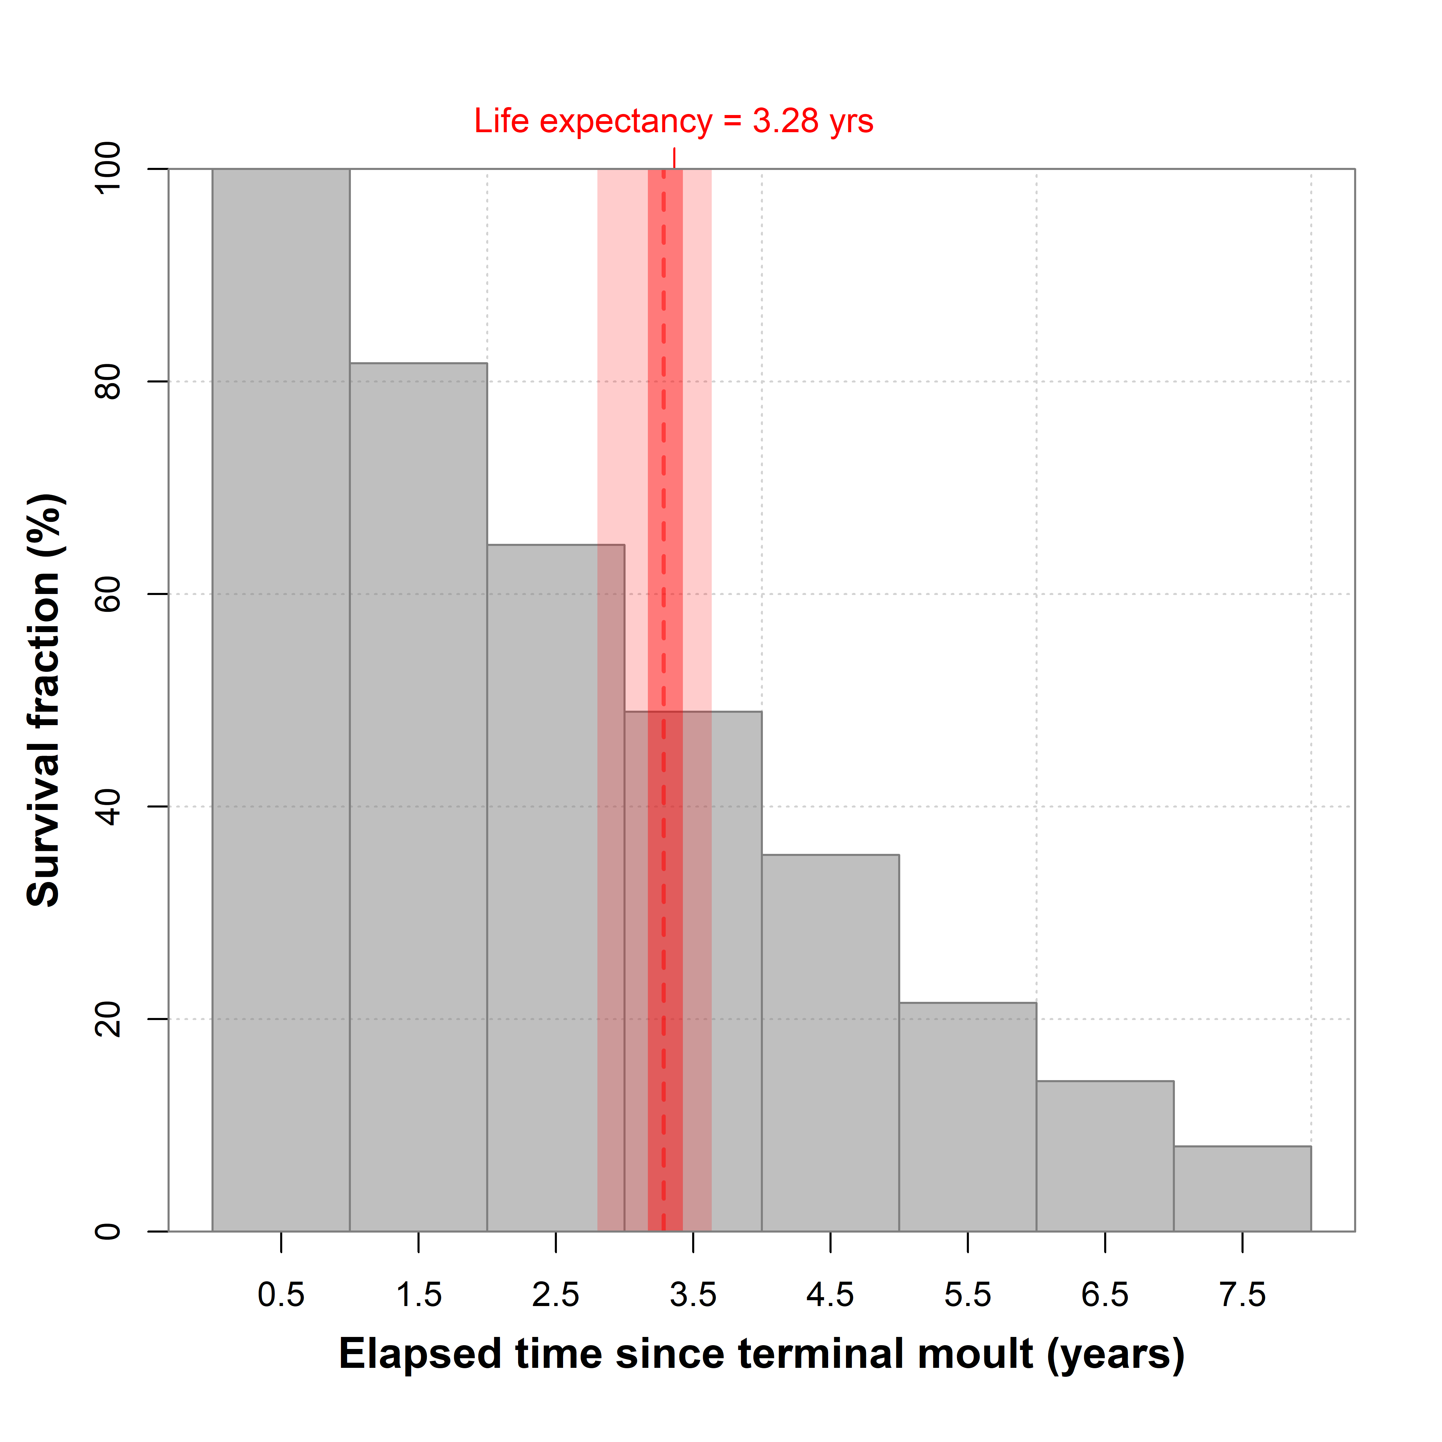
Figure 8 : Estimated survival fraction of mature females after terminal moult. Shown in red is the estimated life expectancy of mature females after terminal moult (interquartile and 95% credibility interval).

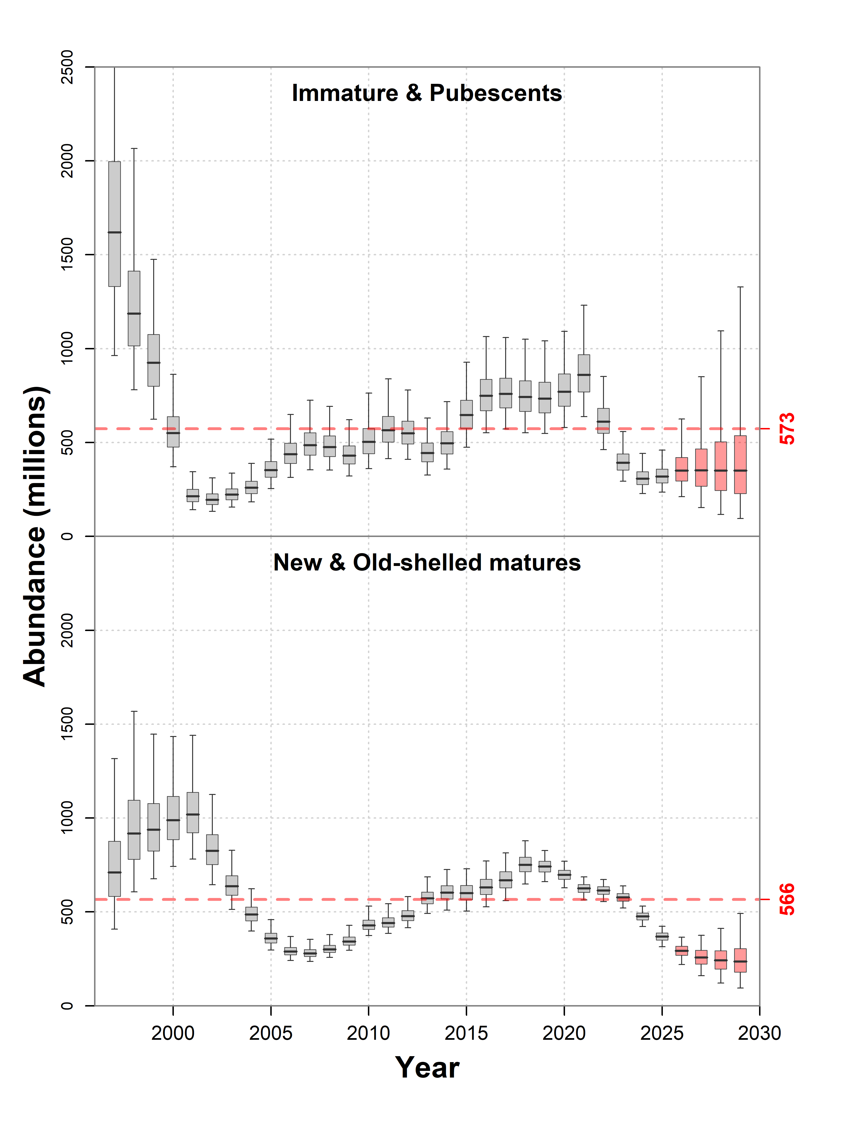
Figure 9 : Population abundance of immatures & pubescents (top panel) and new and old-shelled matures (bottom panel). Red dashed line shows the mean over the time series. Red-shaded boxes indicate projections.

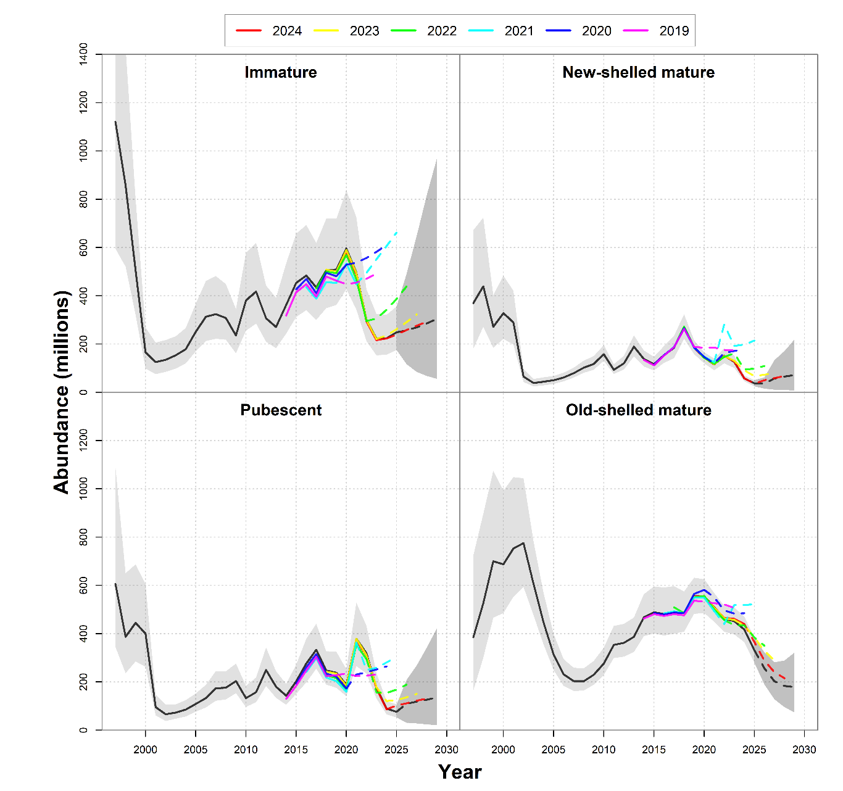
Figure 10 : Population abundance estimates, plus a retrospective analysis, generated by progressively removing survey years from the analysis.
- We see that truncating the time series earlier than 2022 resulted in overly optimistic projections for all maturity stages.
- This indicates that the recent downturn in abundance was not predictable from small recruit abundance data, or that there was a strong increase in mortality during the recent population recruitment pulse.

Annex A
model{
# Recruitment process:
phi.R ~ dunif(0, 1)
alpha.R ~ dnorm(0, 0.001)
mu.R.process <- alpha.R / (1 - phi.R)
tau.R ~ dgamma(0.1, 0.1)
tau.R.process <- (1 - pow(phi.R, 2)) * tau.R
log.R[1] ~ dnorm(mu.R.process, tau.R.process)
mu.R[1] <- exp(log.R[1])
for (i in 2:(n.obs + n.pred)){
eps.R[i] ~ dnorm(0, tau.R)
log.R[i] <- alpha.R + phi.R * log.R[i-1] + eps.R[i]
mu.R[i] <- exp(log.R[i])
}

# Pubescent maturation function:
phi.mat ~ dunif(0, 1)
alpha.mat ~ dnorm(0, 10)
tau.mat ~ dgamma(10,10)
tau.mat.process <- (1 - pow(phi.mat, 2)) * tau.mat
logit.mat[1] ~ dnorm(0, tau.mat.process)
for(i in 2:(n.obs + n.pred)){
eps.mat[i] ~ dnorm(0, tau.mat)
logit.mat[i] <- alpha.mat+phi.mat*logit.mat[i-1]+eps.mat[i]
}
for (i in 1:(n.obs + n.pred)){
p.mat[i] <- 1 / (1 + exp(-logit.mat[i]))
}

# Selectivity coefficients:
S.trawl[1] ~ dunif(0,1) # Immature.
S.pub.tmp ~ dunif(0,1)
S.trawl[2] <- S.trawl[1]+S.pub.tmp*(1-S.trawl[1]) # Pubescent.
for (j in 1:4){
S.vessel[j] ~ dunif(0,1) # Vessel.
}
S.vessel[5] <- 1 # Avalon Voyager II.

# Mortality process:
phi.M ~ dunif(0,1)
tau.M ~ dgamma(0.1,0.1)
tau.M.process <- (1 - pow(phi.M, 2)) * tau.M
for (j in 3:10){
delta.M[1,j] ~ dnorm(0, tau.M.process)
for(i in 2:(n.obs + n.pred)){
eps.M[i,j] ~ dnorm(0, tau.M)
delta.M[i,j] <- phi.M * delta.M[i-1,j] + eps.M[i,j]
}
}
# ‘imm-imm’ and ‘imm-pub’ proportional to pub-new:
for(i in 1:(n.obs + n.pred)){
eps.M[i,1] ~ dnorm(0, tau.M)
eps.M[i,2] ~ dnorm(0, tau.M)
delta.M[i,1] <- delta.M[i,3] + eps.M[i,1]
delta.M[i,2] <- delta.M[i,3] + eps.M[i,2]
}

# Mortality time-series:
mu.M[1] ~ dunif(0, 1)
mu.M[2] <- mu.M[1]
for (j in 3:10){
mu.M[j] ~ dunif(0, 1)
}
for (j in 1:10){
for (i in 1:(n.obs + n.pred)){
M[i,j] <- 1 / (1 + exp(-(log(mu.M[j]) + delta.M[i,j])))
}
}

# Initialize first year:
mu1 ~ dnorm(0, 0.001)
tau1 ~ dgamma(0.1, 0.1)
for (j in 1:4){
mu[1,j] ~ dlnorm(mu1, tau1)
}
for (j in 1:7){
mult[1,j] ~ dlnorm(mu1, tau1)
}

# Population dynamics equations:
for (i in 2:(n.obs + n.pred)){
# Immature:
mu[i,1] <- mu.R[i] + (1-M[i,1]) * (1-p.mat[i]) * mu[i-1,1]
# Adolescent:
mu[i,2] <- (1-M[i,2]) * p.mat[i] * mu[i-1,1]

# Primiparous:
mu[i,3] <- (1-M[i,3]) * mu[i-1,2]

# Multiparous (1st year):
mult[i,1] <- (1-M[i,4]) * mu[i-1,3]

# Multiparous (2nd year):
mult[i,2] <- (1-M[i,5]) * mult[i-1,1]

# Multiparous (3rd year):
mult[i,3] <- (1-M[i,6]) * mult[i-1,2]

# Multiparous (4th year):
mult[i,4] <- (1-M[i,7]) * mult[i-1,3]

# Multiparous (5th year):
mult[i,5] <- (1-M[i,8]) * mult[i-1,4]

# Multiparous (6th year):
mult[i,6] <- (1-M[i,9]) * mult[i-1,5]

# Multiparous (7th year):
mult[i,7] <- (1-M[i,10]) * (mult[i-1,6] + mult[i-1,7])

# Multiparous category:
mu[i,4] <- sum(mult[i,1:7])
}

# Total mature females:
for (i in 1:(n.obs + n.pred)){
mu.imm[i] <- mu[i,1] + mu[i,2]
mu.mat[i] <- mu[i,3] + mu[i,4]
mu.tot[i] <- mu.imm[i] + mu.mat[i]
mu.mat.prop[i] <- mu[i,3] / (mu[i,3] + mu[i,4])
}

# Average mortality:
for (j in 1:10){
M.mean[j] <- mean(M[,j])
}

# Average age-of-death (after terminal moult):
age[1] <- 1 - 0.5
survival[1] <- 1 - M.mean[4]
death.prop[1] <- 1- survival[1]
for (j in 2:7){
age[j] <- j - 0.5
survival[j] <- (1 - M.mean[j+3]) * survival[j-1]
death.prop[j] <- survival[j-1] - survival[j]
}
age[8] <- 8
death.prop[8] <- survival[7] - 0
expectancy <- inprod(age[], death.prop[])

# Observation model:
for (i in 1:n.obs){
# Survey abundance:
mu.N[i,1] <- S.vessel[vessel[i]] * S.trawl[1] * mu[i,1]
mu.N[i,2] <- S.vessel[vessel[i]] * S.trawl[2] * mu[i,2]
mu.N[i,3] <- S.vessel[vessel[i]] * mu[i,3]
mu.N[i,4] <- S.vessel[vessel[i]] * mu[i,4]

for (j in 1:4){
tau.obs[i,j] <- pow(sigma.N[i,j], -2)
N[i,j] ~ dnorm(mu.N[i,j], tau.obs[i,j])
}
}
}

